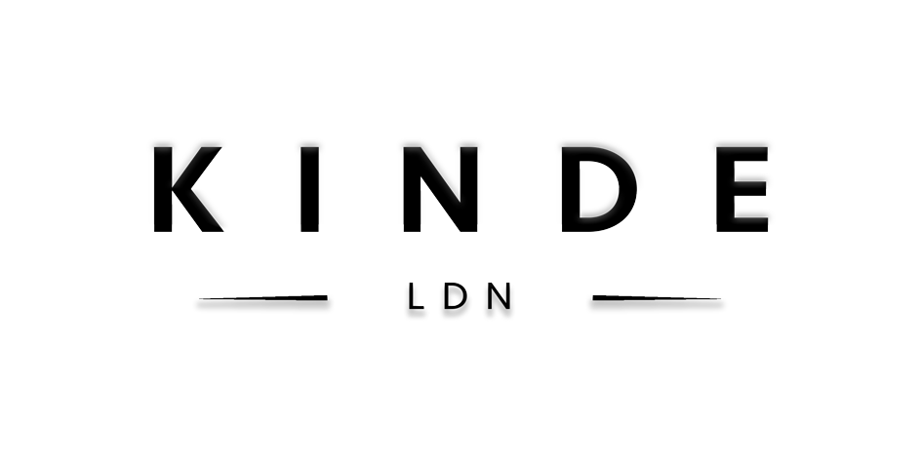

PITCH LIKE A BOSS APPLICATION FORM

Please provide as much information as you can when filling out this application so that we can assess your business idea thoroughly. Please make sure all the answers you provide are honest as any false answers given may affect the success of your application. We may ask you to send over some additional info upon request. We wish you the best of luck in filling this out!

Any question which has a (*) at the start of it; You have the option to record a video or use any other creative means to answer this question. Please send any files alongside this application to the email at the bottom of this form. You will not be awarded extra points for submitting a video or other creative outputs, doing this purely may allow you to be more creative with your answer.

At what stage is your business current at? Please mark the correct box

CONCEPT | PROTOTYPE / START UP | TRADING

Please fill out your personal details below:

PERSONAL
Name
Date of Application
DOB
Home Address
Contact Number
Email
Current Occupation
*Tell us about yourself? Background, other ventures you’ve been involved in, personal experiences? What has bought you to this point? | You have the option to record a video or use any other creative materials to answer this question. Please send any additional files alongside this application to the email at the bottom of this form.

BUSINESS
Business Name
Is this an England & Wales registered company?
Your idea in one line?
*Summary: Tell us everything we need to know about your idea; what problem are you solving (if applicable)? Why is it needed? What makes your idea unique? Any recent sales achieved? Any copyrights, trademarks or patents that you have? Make it count! | You have the option to record a video or use any other creative materials to answer this question. Please send any additional files alongside this application to the email at the bottom of this form. If you do, please clearly provide a description of the attached file in this box. Neither option gets you more points.
Do you currently have a business plan or a proposal of some sort? | If you do, feel free to attach it alongside this application & clearly provide a description of the attached file in this box
Why should you win this cash prize?
What would you do with it? How can this take your business to the next level? Please provide as much detail as you can here. If possible, please provide a rough breakdown.

THE PITCH
Each pitch would last for about 10-15 minutes which will be followed by a 5-minute Q+A by the judging Panel.
Please give us an idea of how you would be looking to present your pitch to our judges? What would be a typical order of events? Would you require any equipment/resources? Any special requests?

FILMING
Have you appeared on any sort of TV, film or branded content before? If yes, please include a link or attach it when sending this application off. See more info below in RETURNS | If you attach a file, please provide a short description of the attached file in this box
This pitching process would be filmed at a venue in London on Thursday 13th February 2020. This is likely to take the whole day so all successful applicants would need to be free for the whole process. | Please indicate here that if successful, you can be available on this date all day.

DECLARATION
I confirm that the information given in this form is true and accurate to the best of my knowledge. I will notify Kinde LDN of any change in circumstances.

Please sign and print your name below
SIGN PRINT

RETURNS
Please return the completed form & any other files you may want to attach ASAP by email:

EMAIL: hello@kindegroup.com
Please include “Full Name: Pitch Like a Boss” in Subject

Unfortunately, due to an anticipated high demand of applicants only those who are shortlisted to the finals may be contacted

PRIVACY
For more information on how Kinde LDN uses your personal data and to find out more about your rights, visit www.kindegroup.com/privacypolicy

